Transfer Standards
# Source: AI Source: Provided by: [Data Path: Persons Table -> ID Column: 1, Name_En Column: Motasem Essam] -> From: [ChatGPT] on [7/17/2026]
Transfer Standards are measurement standards used to transfer the accuracy and traceability of measurements from one laboratory, organization, or location to another. They act as portable reference standards that enable consistent measurements when direct comparison with higher-level standards is impractical or impossible.
Transfer standards are commonly used during interlaboratory comparisons, international measurement comparisons, instrument calibration, and proficiency testing.

Definition
# Source: AI Source: Provided by: [Data Path: Persons Table -> ID Column: 1, Name_En Column: Motasem Essam] -> From: [ChatGPT] on [7/17/2026]
A Transfer Standard is a measurement standard specifically designed to transport or transfer the value of a measurement unit between different locations, laboratories, or calibration facilities while preserving measurement accuracy and traceability.
Unlike other standards, a transfer standard is selected primarily for its stability during transportation and repeated use.

Purpose
# Source: AI Source: Provided by: [Data Path: Persons Table -> ID Column: 1, Name_En Column: Motasem Essam] -> From: [ChatGPT] on [7/17/2026]
Transfer standards are used to:
- Transfer measurement values between laboratories.
- Maintain measurement traceability across different locations.
- Compare measurement capabilities.
- Support interlaboratory comparisons.
- Support international calibration programs.
- Verify consistency between calibration laboratories.

Characteristics
# Source: AI Source: Provided by: [Data Path: Persons Table -> ID Column: 1, Name_En Column: Motasem Essam] -> From: [ChatGPT] on [7/17/2026]
Transfer standards are:
- Highly stable.
- Portable.
- Resistant to environmental changes.
- Traceable to higher-level standards.
- Suitable for repeated transportation.
- Carefully protected during shipment and handling.

Position in the Measurement Hierarchy
# Source: AI Source: Provided by: [Data Path: Persons Table -> ID Column: 1, Name_En Column: Motasem Essam] -> From: [ChatGPT] on [7/17/2026]
A transfer standard is not a separate hierarchical level. Instead, it is used between levels to transfer measurement accuracy.
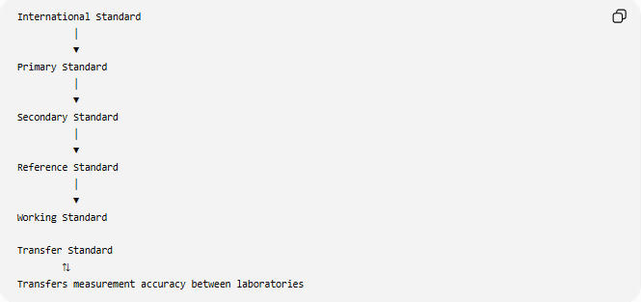
International Standard
│
▼
Primary Standard
│
▼
Secondary Standard
│
▼
Reference Standard
│
▼
Working Standard

Transfer Standard
⇅
Transfers measurement accuracy between laboratories

How Transfer Standards Work
# Source: AI Source: Provided by: [Data Path: Persons Table -> ID Column: 1, Name_En Column: Motasem Essam] -> From: [ChatGPT] on [7/17/2026]
A transfer standard is first calibrated by one laboratory and then transported to another laboratory for comparison.
Laboratory A
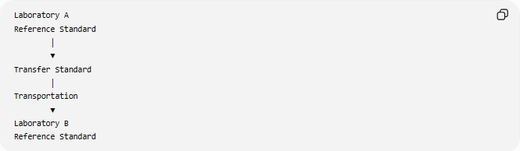
Reference Standard
│
▼
Transfer Standard
│
Transportation
▼
Laboratory B
Reference Standard
The results are compared to evaluate consistency and traceability.

Functions of Transfer Standards
# Source: AI Source: Provided by: [Data Path: Persons Table -> ID Column: 1, Name_En Column: Motasem Essam] -> From: [ChatGPT] on [7/17/2026]
Transfer standards are used to:
- Transfer measurement accuracy.
- Compare laboratory performance.
- Verify calibration consistency.
- Support accreditation.
- Maintain international measurement compatibility.
- Establish traceability across organizations.

Examples of Transfer Standards
# Source: AI Source: Provided by: [Data Path: Persons Table -> ID Column: 1, Name_En Column: Motasem Essam] -> From: [ChatGPT] on [7/17/2026]
Length
- Portable gauge block set.
- Portable laser interferometer.

Mass
- Certified calibration weights transported between laboratories.

Temperature
- Portable platinum resistance thermometer.
- Precision temperature data logger.

Pressure
- Portable pressure calibrator.
- Deadweight tester used for comparison.

Electrical Measurements
- Portable voltage reference.
- Portable resistance standard.
- Portable multifunction electrical calibrator.

Time and Frequency
- Portable atomic clock.
- GPS-disciplined frequency standard.

Traceability
# Source: AI Source: Provided by: [Data Path: Persons Table -> ID Column: 1, Name_En Column: Motasem Essam] -> From: [ChatGPT] on [7/17/2026]
Transfer standards preserve traceability while moving measurements between organizations.
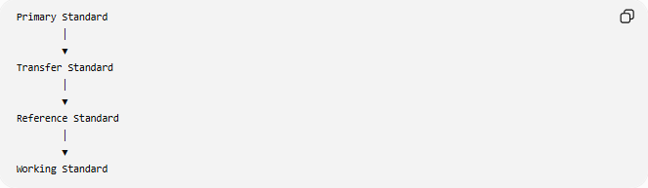
Primary Standard
│
▼
Transfer Standard
│
▼
Reference Standard
│
▼
Working Standard

Calibration
# Source: AI Source: Provided by: [Data Path: Persons Table -> ID Column: 1, Name_En Column: Motasem Essam] -> From: [ChatGPT] on [7/17/2026]
Transfer standards are calibrated:
- Before transportation.
- After transportation (if required).
- Before interlaboratory comparisons.
- Periodically to ensure continued stability.
Calibration records are maintained throughout their use.

Advantages
# Source: AI Source: Provided by: [Data Path: Persons Table -> ID Column: 1, Name_En Column: Motasem Essam] -> From: [ChatGPT] on [7/17/2026]
Transfer standards:
- Enable international measurement consistency.
- Support interlaboratory comparisons.
- Maintain traceability during transportation.
- Reduce the need to move higher-level standards.
- Improve confidence in calibration results.
- Support laboratory accreditation.

Applications
# Source: AI Source: Provided by: [Data Path: Persons Table -> ID Column: 1, Name_En Column: Motasem Essam] -> From: [ChatGPT] on [7/17/2026]
Transfer standards are commonly used in:
- National metrology institutes.
- Calibration laboratories.
- International comparison programs.
- Scientific research.
- Aerospace.
- Manufacturing.
- Electronics.
- Medical equipment calibration.
- Accreditation assessments.
- Quality assurance programs.

Everyday Importance
Although not visible in everyday life, transfer standards help ensure:
- Consistent calibration between laboratories.
- Reliable manufacturing worldwide.
- Accurate medical equipment.
- Fair international trade.
- Comparable scientific research.
- Reliable testing and certification.

Common Mistakes
# Source: AI Source: Provided by: [Data Path: Persons Table -> ID Column: 1, Name_En Column: Motasem Essam] -> From: [ChatGPT] on [7/17/2026]
- Assuming transfer standards are a permanent level in the measurement hierarchy.
- Using ordinary working standards as transfer standards without verifying their stability.
- Ignoring environmental effects during transportation.
- Failing to recalibrate transfer standards after extensive use or transport.

Key Points
# Source: AI Source: Provided by: [Data Path: Persons Table -> ID Column: 1, Name_En Column: Motasem Essam] -> From: [ChatGPT] on [7/17/2026]
- Transfer standards are used to transfer measurement accuracy between locations.
- They are portable, stable, and traceable.
- They support interlaboratory and international comparisons.
- They are calibrated before use and periodically thereafter.
- They are essential for maintaining worldwide measurement consistency.

Transfer Standards vs. Reference Standards
# Source: AI Source: Provided by: [Data Path: Persons Table -> ID Column: 1, Name_En Column: Motasem Essam] -> From: [ChatGPT] on [7/17/2026]
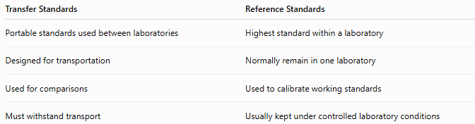
Transfer Standards | Reference Standards
Portable standards used between laboratories | Highest standard within a laboratory
Designed for transportation | Normally remain in one laboratory
Used for comparisons | Used to calibrate working standards
Must withstand transport | Usually kept under controlled laboratory conditions

Transfer Standards vs. Working Standards
# Source: AI Source: Provided by: [Data Path: Persons Table -> ID Column: 1, Name_En Column: Motasem Essam] -> From: [ChatGPT] on [7/17/2026]
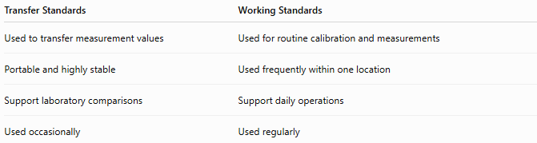
Transfer Standards | Working Standards
Used to transfer measurement values | Used for routine calibration and measurements
Portable and highly stable | Used frequently within one location
Support laboratory comparisons | Support daily operations
Used occasionally | Used regularly

Transfer Standards vs. Secondary Standards
# Source: AI Source: Provided by: [Data Path: Persons Table -> ID Column: 1, Name_En Column: Motasem Essam] -> From: [ChatGPT] on [7/17/2026]
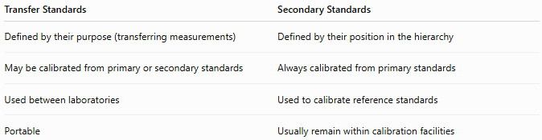
Transfer Standards | Secondary Standards
Defined by their purpose (transferring measurements) | Defined by their position in the hierarchy
May be calibrated from primary or secondary standards | Always calibrated from primary standards
Used between laboratories | Used to calibrate reference standards
Portable | Usually remain within calibration facilities

Conclusion
# Source: AI Source: Provided by: [Data Path: Persons Table -> ID Column: 1, Name_En Column: Motasem Essam] -> From: [ChatGPT] on [7/17/2026]
Transfer Standards are portable measurement standards used to transfer measurement accuracy and traceability between laboratories, organizations, or locations. Rather than representing a separate level in the measurement hierarchy, they serve as a reliable link that enables consistent calibration, interlaboratory comparisons, and international measurement compatibility. Their stability, portability, and traceability make them essential for modern metrology, accreditation, scientific collaboration, and global quality assurance.

